**February 2015**

**Volume 2, Issue 2**

The Wave

***Upcoming Middle School Events***

Valentine’s Day Dance

February 6th

Valentine’s Day

February 14th

February Break

February 16th – 20th

Musical

February 26th – 28th

7:00

St. Patrick’s Day

March 17th

Spring Break

March 30th – April 6th

***Individual Highlights***

Reviews 2

Interviews 3

Student Corner 4 - 5

# Staying Healthy

Recently, there has been an outbreak of Influenza A. Chances are, you or someone you know has gotten it. Influenza A is hitting people of every age: babies, teenagers, and the elderly. Here are a few tips to keep you healthy.

* Wash your hands. Your hands pick up a plethora of germs! Be sure to wash your hands, especially before you eat.

* Get the flu shot. You can still catch this strand of the flu, but it will help prevent you from catching Influenza B. You can get the flu shot with your parents right at Walgreens.

* If you think you have the flu, stay home! You can spread the flu to others if you go out when you are ill.

* Give your body time to recover. Influenza A really has taken a toll on people and sometimes people have gotten sicker due to pushing their bodies before they are ready.

By: Haley Murray

6th Grade

## Stories from the Storm

November of 2014 has been renamed Snowvember after the horrible snow storm our area encountered during that time. This storm was tragic for some people’s homes, businesses, and even lives, but the one thing it showed me is how strong our community is and how caring members of our community are!

Many people experienced acts of kindness during the storm, including my family. My family ran low on food. A friend of ours from down the road knew this so she walked down to a local store and brought us back some food.

Other people in our neighborhood helped shovel driveways, shovel off roofs, some people even drove on snowmobiles to get medications for the elderly.

Although the storm was difficult, it brought out good in many.

By: Haley Murray

Julie Ann Ketcher

6th Grade



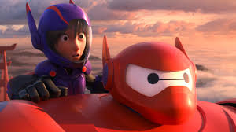

Other activities in the game include exploration, gathering resources crafting, and combat. Multiple gameplay modes are available, including [survival modes](http://en.wikipedia.org/wiki/Survival_mode) where the player must acquire resources to

build the world and maintain health, a [creative mode](http://en.wikipedia.org/wiki/Minecraft#Creative_mode) where players have unlimited resources to build and the ability to fly, and an [adventure mode](http://en.wikipedia.org/wiki/Minecraft#Adventure_mode) where players play custom [maps](http://en.wikipedia.org/wiki/Level_%28video_gaming%29) created by other players.

By: Gabrielle VonGunden

6th Grade

The video game, Minecraft, has been the talk of many middle school students around the world.

Minecraft allows players to build constructions out of textured cubes in a [3D](http://en.wikipedia.org/wiki/3D_computer_graphics) [procedurally generated](http://en.wikipedia.org/wiki/Procedural_generation) world.

## Video Game Review

## Movie Review

## Book Review

Blog. Penny enjoys photography also. She also suffers from panic attacks. I feel as many readers may be able to relate to Penny. This book is good for someone who has no experience with writing. I give this book 8 out of 10 stars.

By: Mackenize Kwilos

6th Grade

The young adult does do a phenomenal job telling readers about all the characters’ personalities. After a little bit of reading, you can feel as if you know all the characters. In the book Penny has a blog where she can write her troubles. She keeps all names secret, so that no one discovers this

Girl Online is a book written by Zoella, a youtuber/beauty blogger. The main character in Girl Online is Penny. Zoella describes her having orange hair and freckles. Although the author doesn’t use much imagery, we can still picture the characters pretty well.



This loveable character makes the movie funny, but also makes you cry because of his loveable heart. Out of five stars I give this movie a 3.

Big Hero 6 was released in 2014 and is a computer animated superhero fantasy-comedy film produced by Walt Disney Pictures. It was inspired by Marvel Comics. The movie is about a young teenage boy who is into

robotics. After some tragic events in his life, Hiro forms a superhero team to combat a masked villain. In his team of genius superheroes, is the loveable robot named Beta Max.

## Interview with Mrs. Agro

Recently, I stayed after with Mrs. Agro to find out some things about her, besides her love for music. Here is what Mrs. Agro had to say when I interviewed her.

Me: What college did you go to?

Mrs. Agro: I went to Roberts Wesleyan College

Me: What was your favorite song when you were in Middle School?

Mrs. Agro: I didn’t really have a favorite song. I liked to sing all of the time though. Some that I can recall listening to a lot were *Les Mis Medley* , that came out when I was in High School, and *Beauty and the Beast* as well.

Me: Did you ever play an instrument?

Mrs. Agro: I played the clarinet for eight years, but I currently play the piano.

Me: If you were in a play, what play and what part would you want to be?

Mrs. Agro: I would play Cosette in Le Mis or be in Thoroughly Modern Milly.

Me: You told us in class you saw the new movie, Into the Woods. Do you like the play or the new movie better?

Mrs. Agro: Yeah, I would have to say that the singers and the original composers are better. I just really like Bernadette Peters, one of the original singers.

Me: What would you rate Into the Woods?

Mrs. Agro: Personally, I would give it 4 out of 5 stars.

Mrs. Agro is an essential part of the music department and it is obvious she is passionate about her job and music. I had a great time interviewing her. Thank you for your time Mrs. Agro!

By: Megan Kowalski

6th grade

Mrs. Agro not only loves to sing, but she also plays the piano and used to play the clarinet.

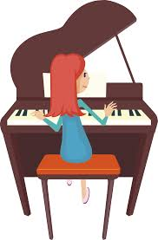

## Interview with Mrs. Fricano

Mrs. Fricano is my ELA teacher and concerned all of us when she came down with the flu after break. Here what she had to say about being sick over Christmas and about some other things.

Me: How long were you sick with the flu?

Mrs. Fricano: I was sick a long time, about 12 days.

Me: What were some of the side effects of the flu?

Mrs. Fricano: I had a horribly high temperature, I would shiver a lot, my teeth would chatter, and I also would become very hot.

Me: How do you think you caught the flu?

Mrs. Fricano: I really don’t know. Maybe while I was Christmas shopping, or being a teacher and being around all of the kids? Obviously I was exposed to someone sneezing on me or something.

Me: What is your favorite book?

Mrs. Fricano: I am actually in the middle of reading I, Elizabeth, which is about Queen Elizabeth.

Me: Do you think we needed all of those snow days?

Mrs. Fricano: Yes, I would rather be safe and have all the students be safe and my colleagues be safe as well. I also don’t like driving in bad weather!

Thank you Mrs. Fricano for your time and we are glad you are back and healthy!

By: Mackenzie Kwilos

6th Grade

“I don’t like driving in bad weather!”

## Valentine’s Day

Each year on February 14th, people of all ages exchange cards, candy, stuffed animals, and flowers to people who are special to them. Have you ever thought why we go through the trouble of doing this every year?

Legend has it that a priest named Bishop Valentine was given the job of performing the sacraments to Catholic followers in Rome, including the sacrament of marriage which was outlawed at the time by Emperor Claudius II. Claudius jailed Valentine for secretly trying to perform marriage ceremonies for men in the military. Claudius felt that married men made bad soldiers.

While Valentine was awaiting execution Valentine performed a miracle by curing the blindness of Julia, the daughter of his jailer, Asterius. This is how he became a saint.

Another legend about St. Valentine is his wish to remind the soldiers of God’s love and to encourage them to remain faithful to their religions. He is said to have cut hearts from parchment, giving them to the soldiers. This is possibly the origin of the modern tradition of hearts representing love.

Another strange story about Valentine is that he is said to have written the very first Valentine ‘s card the night before he was executed. He wrote it to the daughter of Asterius who was now no longer blind. He signed the card “Your Valentine!” which is how we commonly sign anonymous Valentine ’s Day cards today.

Today Valentine’s Day has become very commercial so keep the story of Saint Valentine in your mind as you spend money on your special someone.

By: Julie Ann Ketcher

6th Grade

*When did Valentine’s Day start?*

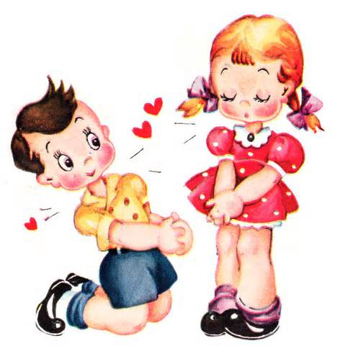

Dear Blabby: One of my best friends is mad at my other friend. They won’t talk or sit next to each other. I need them to make up. What should I do?

Signed: Stuck in the Middle

Dear Stuck in the Middle:

If your friends are fighting try to remind them of why you are all friends in the first place. Talk about memories you have made with one another. This could help them remember the important parts of their friendship.

If you are a student in need of advice about love, school, sports, family, friends, or anything that is bothering you, write your question down on a piece of paper and place it in the envelope outside of Mrs. Conrad’s room, room 109, labeled Dear Blabby, and we will give you our best advice in the next issue of The Wave.

Your questions should remain anonymous and be appropriate.

## Dear Blabby – What’s It All About?

Did you know our school newspaper has an advice column?

Get the answers to your questions in our next edition!

In the last issue of The WAVE we told the student body that our school was missing HONESTY. It was found! The students in our story asked to remain anonymous

A science teacher had given an assignment to her students for homework. In class the following day the students were asked to switch their papers with a partner so that it could be corrected and taken for a grade. The students went through the entire worksheet with the teacher, put the grade on the top, and gave their partner their paper back. One of the students in the class noticed that his partner didn’t mark two of his answers wrong when they were in fact done incorrectly. The student took it upon himself to go up to the teacher and tell her that his partner had marked two correct that were wrong. The teacher was so impressed with this students honestly that she ended up giving him a 100% on the assignment!

What would you have done in this situation? Would you have kept quiet and not told the teacher about the mistakes your partner had made, or would have been honest, and told the teacher?

By: Megan Kowalski

Abbey Hanes

6th Grade

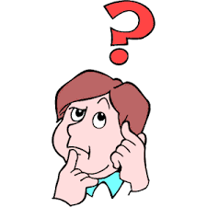

Missing: CREATIVITY

If you see an example of **creativity** this month portrayed by one of your classmates tell “The Wave” staff about it. Grab a “Missing” sheet outside of room 109 and submit your story to Mrs. Conrad. Your story might be put in the next edition of “The Wave!”

By: Megan Kowalski

Abbey Hanes

**Aquarius: Jan. 21 – Feb. 19th**

This month you will be a little on the shy side. Dig deep and reveal your inner self. It may help you meet a life long friend.

**Pisces: Feb. 20th – March 20th**

You have the ability to help out others. Try to use this great quality to help people around you.

**Aries: March 21st – April 20th**

You should spend some time with your family this month. You may be surprised by the outcome.

**Taurus: April 21st – May 21st**

You will have the opportunity to do something that you love this month. Don’t miss it!

**Gemini: May 22nd – June 21st**

Learn how to cooperate with others this month. Not doing so will get you in trouble.

**Cancer: June 22nd – July 23rd**

You will be looked to for your leadership skills this month. Be sure to lead people in the right direction.

**Leo: July 24th – August 24th**

You are being admired by something you least expect. Be sure to be on the lookout for this around Valentine’s Day.

**Virgo: August 25th – September 23rd**

You are being pulled in a million directions this month. Be sure to keep your priorities straight and pay attention in class.

**Libra: September 24th – October 23rd**

You will have a hard time making decisions this month. Look for guidance from caring adults to help you.

**Scorpio: October 24th – November 22nd**

You have a hidden talent that will come out this month. Find a way to use it!

**Sagittarius:** **November 23rd – December 22nd**

Life doesn’t always go as planned. Learn how to go with the flow.

**Capricorn: December 23rd – January 20th**

You may not get any valentine’s this month because someone is too scared to tell you how they feel.

By: Megan Kowalski

Grade

##### FOUND: HONESTY Horoscopes